1. 
2. We will see some data enrichment by using some filter plugins.
3. One example of data enrichment is to take the IP Address and perform geographical lookup to resolve the visitor’s country, city and many more.
4. Let’s see how.
5. This is very easy and thanks to the **Geo-IP filter Plugin**.
6. This plugin comes with **GeoLite 2 DB** (by default) provided by Company MaxMind.
7. This company is very popular source of geographical data.
8. It is possible to use other databases as well by specifying an option which may improve accuracy, but we will use default DB because that is available for free of charge.
9. Let’s add the **geoip filter plugin**. The following one is for 6.0.0 and will not work for 8.8.0. See next slide after this.
10. A picture containing text, screenshot, diagram

    Description automatically generated  
    The following for 8.8.1 we have [source][address] property not clientip  
    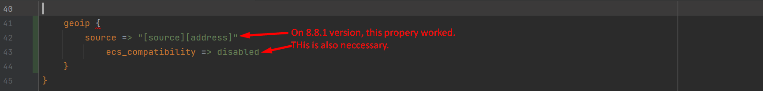
11. 
12. Within the terminal, now we can see a new field “geoip” containing various info about the geographical location of the visitor based on ip address.
13. Let’s study the output:  
    A screen shot of a computer

    Description automatically generated with medium confidence
14. Two things before ending this lecture:
    1. If geoip plugin fails looking up the geographical location, it will add a tag named **geoip_lookup_failure**.
    2. Geoip plugin plays well with Elasticsearch output.  
       This is because there is nested object named **location** within the **geoip object** which contains latitude and longitude pair.  
       This object uses a format named **GeoJSON** which is a standard format for representing **geospatial** data in JSOn.  
       This is the same format that Elasticsearch uses for geo_point data type. Meaning you can use the powerful geospatial queries of the elasticsearch or Kibana’s tool for working with Geographical data.